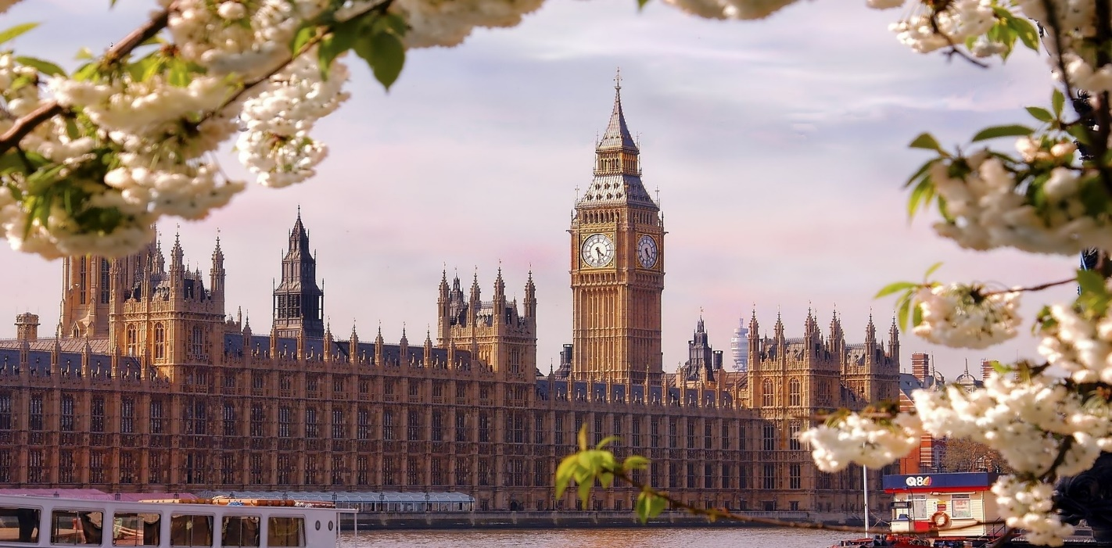

Тематический контроль
Приложение к учебнику по английскому языку для 8 класса
УМК «EnjoyEnglish» разработан на основе предметной линии учебников
М.З. Биболетова, О.А. Денисенко, Н.Н. Трубанева. – Обнинск: Титул, 2014.

Выполнила
учитель МБОУ СОШ№ 16
Пантелей Виктория

Содержание

UNIT 1 It is a wonderful planet we live on 3
Section 1 3
After rain comes fine weather 3
Section 2 5
We are part of the Universe 5
Section 3-4 7
Who is there ? Exploring space 7
Section 5-6 9
Is the Earth a dangerous place? 9

UNIT 1 It is a wonderful planet we live on

Section 1

After rain comes fine weather

Test 1
1.Put the correct word in each gap.

snow summer rains cloudy sky sunny
The weather in Scotland changes a lot. In winter there is 1 ______________ on the mountains and you can go skiing. Sometimes the 2 _________________ is blue and it's beautiful but sometimes it's 3__________________You need warm clothes in winter and it 4__________a lot, so you need an umbrella. In 5 ________
it is a good time to go there for a holiday.
It is often warm and 6_____________so it is a good time to go there for a holiday.

2. Rearrange the letters to find words. Use the definitions to help you.
1. cei _________ (It's dangerous to drive when this is on the road.)
2. ygogf _________ (It's difficult to see in this kind of weather.)
3. nidwy _________ (It's difficult to use an umbrella in this kind of weather.)
4. olucd _________ (This is a white or grey thing in the sky.)
5. mumser _________ (It is hotter than the other times of the year.)
6. nwos _________ (This is white and cold and falls from the sky.)

3. Translate the following sentences from English into Russian:

1. I think spring will be cold -
2. There will be a storm tomorrow –
3. If there is frost schoolchildren will not go to school –
4. It is going to be sunny -

4 .Choose the correct word.
1. There's a big white wind / rain / cloud in the sky.
2. Oh no! It's raining so we will get warm / wet / hot.
3. The weather / sky / cloud was warm when we were on holiday.
4. I like wind / winter / summer because I can go skiing then.
5. It was cold / foggy / sunny yesterday so we went to the beach.
6. I can't see the top of the mountains because there's a lot of weather
/ sky /fog.

5. Choose the right answer.

- In Russia it’s … in winter
- hot b) cloudy and sunny c) foggy d)snowy
2. It’s Sunny in Spain today, isn’t it?- Yes, it’s … ,isn’t it.
a)terrible b) lovely c) miserable d) awful
3. She likes swimming in … sea.
a) - b) a c) an d) the

6. Translate from Russian into English:
1. Зимой здесь обычно становится холодно и морозно.
2. Летом всегда жарко.
3. Было достаточно тепло. Температура была +5 выше нуля.
4. Погода в Британии быстро меняется.
5. Летом в городе немного душно.

Section 2

We are part of the Universe

Test 2
- Choose the correct variant:
- … is the Sun together with the planets going round it.
  - the solar system b) a galaxy c) a planet.

- … is a large, round object that goes round a star.
  - space b) the universe c) a planet

- … is a very violent wind in the form of a runnel of air that spins at great speed.
  - a flood b) a tornado c) a hurricane

- … is a sudden shaking of the ground.
  - an earthquake b) a drought c) a volcano

    - … is a group of stars to which the Sun and its planets belong.
      - Galaxy b) The Milky Way c) The Moon

- Match. Each word can be used only once.

1. to travel to  2. intergalactic  3. to launch  4. to wear  5. to live in | a) a spacesuit  b) other galaxies  c) a space station  d) a satellite  e) spaceship

3.Put the words in right order and translate the sentences.

- music, I, a long, for, have not, time, listened, to.
- Galileo, telescope, the first, made, it, and, looked through.
- were, something, They, interesting, looking at, more.
4) careful, should be, spacemen, with, very, their, spacesuit.

4. Прочитайте слова. Найдите их значения на русском . Заполните таблицу.
1. Telescope . 2.The Earth. 3. The Galaxy 4. Stormy. 5. Pole. 6. Satellite.
7. Humid.8. The Universe. 9. Wet. 10. The Moon.
a) Земля b) Мокрый с) Луна d) Полюс е) Влажный / сырой
f) Телескоп g) Спутник h) Штормовой i) Вселенная j) Галактика.
1 | 2 | 3 | 4 | 5 | 6 | 7 | 8 | 9 | 10

5. Put verbs in Past Simple and Past Continuous.
1. They (to drink) tea when I (to come) home.
2. When I (to enter) the classroom, the teacher (to write) words on the blackboard and the pupils (to copy) them into their exercise-books.
3. They (to get) ready to go out when it (to begin) raining.
4. When he (to come) in, I (to do) my exercises.
5. You (to sleep) when I (to go) out.

6.Choose the correct variant .
1.Volga is the longest river in Europe.
- the b) –
2 . United Kingdom consists of Great Britain.
- – b) the
3.The unusual town is situated near … Lake Onega.
- the b) –
4.The capital of … USA is Washington.
- – b) the
5.Have you ever been to … Baikal?
- the b) –
6.She likes swimming in … sea.
- – b) the
7. Russia is a big country.
- the b) –
8.I live in … Russian Federation.
- – b) the

Section 3-4

Who is there ? Exploring space

Test 3
1.Which is right? Complete the sentences.
1. Не (slept / was sleeping) when his mother (came / was coming) back.
2. On Monday while he ....................... (cooked / was cooking) lunch
the postman ....................... (brought / was bringing) him a letter from his friend.
3. When the teacher.......................... (came / was coming) into the classroom,
the children .......................(sat / were sitting) at their desks.
4. One day while she ........................... (read / was reading) a book, a big black
fly .................. (sat / was sitting) down on her book.
5. We .............................. (read / were reading) a text, then
w e ........................(answered / were answering) the teacher’s questions.
After that w e ............................ (did / were doing) grammar exercises.

2. Match the pairs.
1. to learn a lot from space research  2. to solve different scientific problems  3. to launch a spaceship  4. Space exploration | a) Исследование космоса  b) Запускать космический корабль  c) многое узнать из космических исследований  d) решать различные научные задачи

3. Write the sentences using the Past continuous.

- David and Helen / play / tennis
_______________________________________
- Mary / lie / on the grass
_______________________________________
- The birds / fly
_______________________________________
- Tom and Bridget / sit / under a tree
_______________________________________
- Sam / write / his diary
_______________________________________
- Alan / answer / the phone
_______________________________________

4.Translate from Russian into English.
1. с двух часов ...............................................
2. с воскресенья ...............................................
3. с августа ...............................................
4. с 1995 ...............................................
5. c утра ...............................................
6. в течение двух минут ..............................................
7. в течение двух дней ...............................................
8. в течение двух недель ..............................................
9. в течение двух месяцев ..............................................
10. в течение двух лет .............................................

5.Fill in Since or for.
1. She has been studying at the library ........... two o’clock.
2. She has been studying at the library ...........two hours.
3. They have been talking ...........an hour.
4. They have been talking ...........a long time.
5. They have been talking ...........ten minutes.
6. I have been helping Mother........... morning.

6. Make up sentences. Write the down.
1. going / I / been / have / to / this / school / five / for / years
2. has / He / since / he / was / at / school / English / primary / been / learning
3. have / been / seeing / recently / We / much / our / not / Aunty / very
4. you / garden / working / Have / in / the / been / ?
5. has / hours / to / his / MP3 / been / three / He / player / listening / for
6. football / My / team / have / not / very / doing / this / well / been / month
7. you / recently / going / Who / out / been / with / have / ?

Section 5-6

Is the Earth a dangerous place?

Test 4
1.Choose the correct answer.

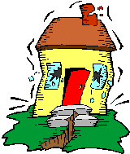 | 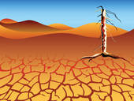 | 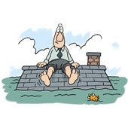 | 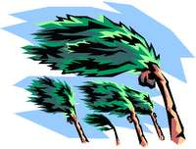 | 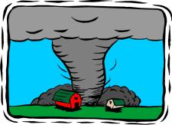
a) Earthquake  b) Earth tremor  c) Earth shiver | - Desert  - Drought  - Island | - Storm  - Thaw  - Flood | - Gale  - Draught  - Hurricane | - Landslide  - Tornado  - Whirlwind
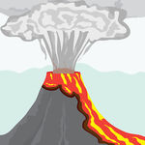 | 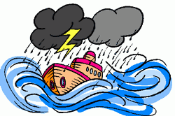 | 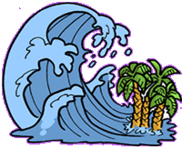
- Landslide  - Tornado  - Whirlwind | - Calm sea  b) Storm at sea  c) Thunderstorm | a) Roller-coaster  b) Topsy-turvy  c) Tsunami | - Blizzard  b) Snowstorm  c) Avalanche | - Typhoon  - Cyclone  - Tornado

2. Choose the sentences to the following words: volcano eruption; drought; hurricane; earthquake; flood

1. It lifted a car at about ten feet off the ground, and then we saw it disappear down the street.
2. It was about two meters deep and we watched as most of our furniture just floated away.
3. The grass turned yellow and most of the crops died.
4. The walls began to move visibly, and large cracks opened up in the ground.
5. We could see the slowly advancing towards the town just ten miles away.

3.Put verbs in Past Simple and Past Perfect

1. The terrible hurricane… (destroy) all the houses by that time.
2. The pilot … (finish) his flight by 3 p. m. yesterday.
3. When the professor … (come), the students … already (collect) their thoughts.
4. She … already (read) the article, when I … (phone) her.

4. Make the word combinations
1. limit  2. monitor  3. broadcast  4. evacuate  5. rescue  6. warn | a) messages  b) of a rainstorm  c) the speed  d) the water  e) from flood  f) people

5. Past Simple or Past Perfect ?

Divide tense markers into two columns.
Past Simple | Past Perfect
By Wednesday, two weeks ago, the day before yesterday, last week, when mum came, before my friend phoned, in 2013, by that time, long ago
6. Choose the correct form of the verb.

1. Mr Potter repaired / had repaired his car yesterday.
2. Our grandma baked / had baked a carrot cake by 6 o’clock yesterday.
3. He wrote / had written an article by Monday morning.
4.Tim and Betsy had been / were in Peru three years ago.
5. Did you water / Had you watered the flowers the day before yesterday?
6. John read / had read a book by Agatha Christie by the 1st of November.
7. My brother had flown / flew to Berlin last spring.
8.The children cleaned / had cleaned the flat before their parents returned.

